W316R,W308R,W309R-How to change the LAN IP address?
Product line: wireless question category: function config

Q: Why do we need to change the LAN IP address?
A: Sometimes you cannot get online when you have done the setup wizard, which might be that your modem and Tenda router have the same IP address. In this regard, you have to change the LAN IP address of the router.

Steps are as following:
1, Login the management page of the router.(the login IP is default to be 192.168.0.1)
2, click Advanced settings→LAN settings following the picture as below.
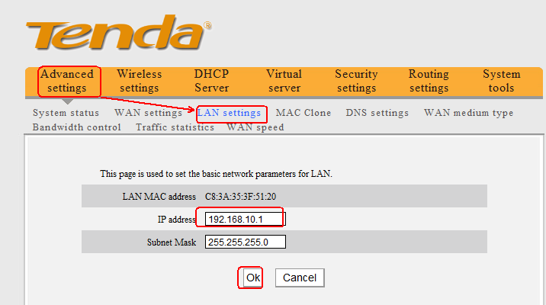
After click ok, the router will reboot itself.
The default LAN IP address of Tenda router is 192.168.0.1. You can change the LAN IP address to 192.168.10.1, then click Apply and the router will reboot. After the router finishes rebooting, please login with new ip address. Type http://192.168.10.1 in the address bar in web browser to login.

